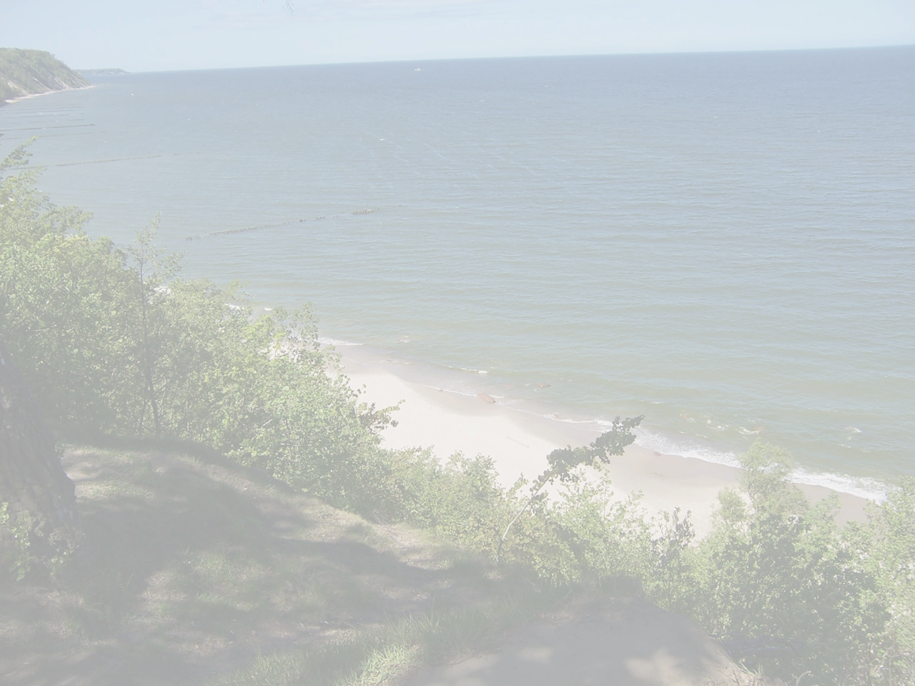
THE 2nd VGIK INTERNATIONAL SUMMER SCHOOL
Rostov region
July 18 - August 8, 2010

Film School
Rules and Regulations

1. Introduction.
The 2nd International Summer School (July 18 – August 8, 2010) in the Rostov Region is organized by
- Russian State University of Cinematography n.a. S.Gerasimov (VGIK)
under the patronage of :
- Ministry of Culture of the Russian Federation
- Rostov Region Government.

The aim of the school:
-to acquire additional knowledge and training in the profession.
-to develop academic and creative film production contacts between the students of European and CIS film and drama schools.
-to expand the knowledge of life and culture of the participant countries.
-to create visual images of the country through film students eyes.

2. The academic and film production activities.
Within the framework of the summer school the students of Direction, Cinematography, Film production departments of the European and CIS schools will get together in the Rostov region to:
• to attend master-classes of the leading European and Russian filmmakers,
• to present and discuss their stories on the proposed theme,
• to explore the area of the shooting,
• to shoot a 10-minute documentary film on the theme “South of Russia : History and Modern Reality “

3. The language of the School: English.

4. Students are to submit by May 10, 2010:
- correctly filled-in application form
- electronic photo
- copy of their film work (in DVD) made during studies at their schools (documentary or feature, subtitled in English or with English dialogue lists)
- Synopsis or notes explaining the desire or the vision of the story to be shot in Rostov area.

To learn more about history and culture of the towns and cities of the Rostov region one may use the following links:
http://www.donland.ru/english/about/
http://www.eecl.org/cities/azov/history.shtml
http://sagavoyages.ru/azov.html

5. The conditions of staying:
a) VGIK provides:
- board and lodging for the participants
- equipment and materials for film production (mini DV-format)
- local transport
- a DVD with the collection of films made by Summer School participants

b) The participants pay for:
- getting a Russian visa (if not agreed between the Embassy of Russia and the country of the participants in the state agreement)
- international travel health insurance

6. Contacts:
RUSSIAN STATE UNIVERSITY OF CINEMATOGRAPHY
named after S. Gerasimov (VGIK)
W. Pieck str. 3, Moscow, 129226-RU
International Department: (499) 181 26 80;
Fax: (499) 181 80 74;
E-mail: foreign_vgik@mail.ru

Best regards,

Vladimir Phokin,
Director-in-Chief

